Restore

What is Restore?
# Source: AI Source: Provided by: [Data Path: Persons Table -> ID Column: 1, Name_En Column: Motasem Essam] -> From: [ChatGPT] on [2/15/2026]
In Git, restore means bringing files back to a previous state (usually from the last commit or from the staging area). It is mainly used to undo changes in files.
Git introduced restore to replace the file-restoring part of checkout.

What git restore does
# Source: AI Source: Provided by: [Data Path: Persons Table -> ID Column: 1, Name_En Column: Motasem Essam] -> From: [ChatGPT] on [2/15/2026]
It can:
- Discard changes in working directory (undo edits)
- Unstage files (remove from staging area)
- Restore file from a specific commit

1. Restore file (discard local changes)
# Source: AI Source: Provided by: [Data Path: Persons Table -> ID Column: 1, Name_En Column: Motasem Essam] -> From: [ChatGPT] on [2/15/2026]
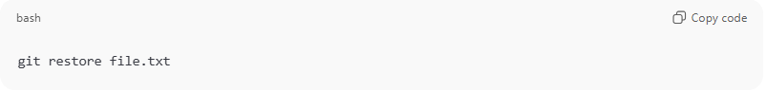
git restore file.txt
- Removes changes in working directory
- File returns to last committed version
- Staging area unchanged
⚠️ Your edits are lost.

2. Restore staged file (unstage)
# Source: AI Source: Provided by: [Data Path: Persons Table -> ID Column: 1, Name_En Column: Motasem Essam] -> From: [ChatGPT] on [2/15/2026]
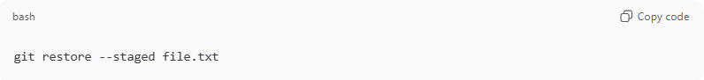
git restore --staged file.txt
- Removes file from staging area
- Keeps file changes in working directory
Same as:
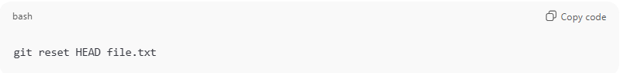
git reset HEAD file.txt

3. Restore file from a specific commit
# Source: AI Source: Provided by: [Data Path: Persons Table -> ID Column: 1, Name_En Column: Motasem Essam] -> From: [ChatGPT] on [2/15/2026]
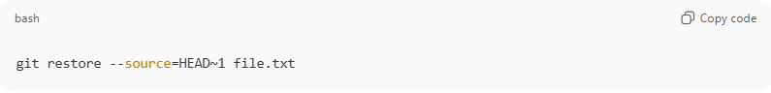
git restore --source=HEAD~1 file.txt
- Gets file version from older commit
- Replaces current file in working directory

Restore vs Clean vs Reset vs Checkout
# Source: AI Source: Provided by: [Data Path: Persons Table -> ID Column: 1, Name_En Column: Motasem Essam] -> From: [ChatGPT] on [2/15/2026]
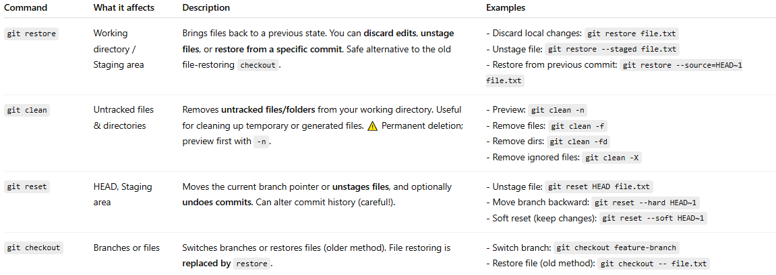
Command | What it affects | Description | Examples
git restore | Working directory / Staging area | Brings files back to a previous state. You can discard edits, unstage files, or restore from a specific commit. Safe alternative to the old file-restoring checkout. | - Discard local changes: git restore file.txt - Unstage file: git restore --staged file.txt - Restore from previous commit: git restore --source=HEAD~1 file.txt
git clean | Untracked files & directories | Removes untracked files/folders from your working directory. Useful for cleaning up temporary or generated files. ⚠️ Permanent deletion; preview first with -n. | - Preview: git clean -n - Remove files: git clean -f - Remove dirs: git clean -fd - Remove ignored files: git clean -X
git reset | HEAD, Staging area | Moves the current branch pointer or unstages files, and optionally undoes commits. Can alter commit history (careful!). | - Unstage file: git reset HEAD file.txt - Move branch backward: git reset --hard HEAD~1 - Soft reset (keep changes): git reset --soft HEAD~1
git checkout | Branches or files | Switches branches or restores files (older method). File restoring is replaced by restore. | - Switch branch: git checkout feature-branch - Restore file (old method): git checkout -- file.txt

Visual/Conceptual Map
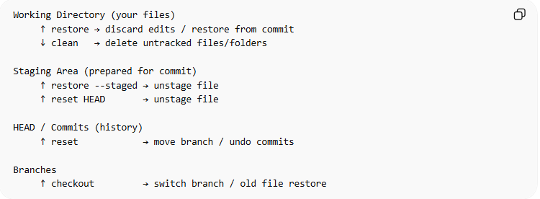
Working Directory (your files)
↑ restore → discard edits / restore from commit
↓ clean → delete untracked files/folders

Staging Area (prepared for commit)
↑ restore --staged → unstage file
↑ reset HEAD → unstage file

HEAD / Commits (history)
↑ reset → move branch / undo commits

Branches
↑ checkout → switch branch / old file restore

💡 Quick Tip:
Think of Git like a workshop:
- restore → fixes a broken tool (your file)
- reset → rolls back the project plan (commits or staging)
- clean → throws away trash (untracked files)
- checkout → moves you to a different workspace (branch)

Common real-life uses
# Source: AI Source: Provided by: [Data Path: Persons Table -> ID Column: 1, Name_En Column: Motasem Essam] -> From: [ChatGPT] on [2/15/2026]
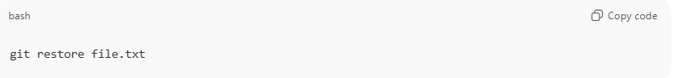
Undo file changes:
git restore file.txt
Unstage file:
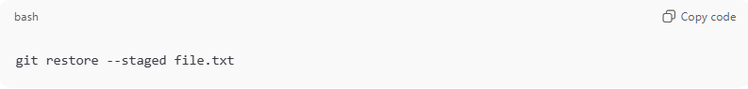
git restore --staged file.txt
Restore everything:
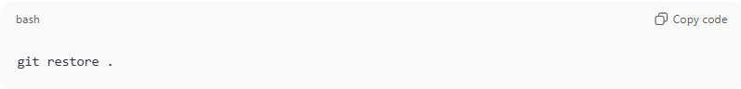
git restore .

Simple idea
# Source: AI Source: Provided by: [Data Path: Persons Table -> ID Column: 1, Name_En Column: Motasem Essam] -> From: [ChatGPT] on [2/15/2026]
- Working directory → where you edit files
- Staging area → prepared for commit
- Restore → bring file back from staging or last commit

